Affordable drone platform for use in education

September 10, 2016

Authors: Sundaramahalingam Sudharshan, Isaac Tay Eng Hian, Prahlad Vadekkepat

# Introduction

The drone industry has been experiencing steady expansion in recent years, seeing a market growth from a 552 million USD industry in 2014, to 1.4 billion USD in 2015 with an expected forecast of 5 billion USD in 2017.[1] Numerous research papers have been published on applying drones to practical uses excluding recreation like agriculture, surveillance, security and industrial automation. One notable area of research is into its use as a military attack platform where the industry is estimated to hit 1.8 trillion by 2017.[2] Additionally, Unmanned Aerial Vehicles (UAVs) have high potential in the agriculture industry where they are being used to crop and monitor large plantations and vegetation.[3] More specialized applications like those where drones are used in mosquito vector control[4] and oil spill detection monitoring[5] are also being investigated by researchers.

Similarly, the education industry is trying to integrate drones into the curriculum and research is being conducted into drones as a platform for robotics research and education.[6] Research has shown that providing researchers and students with software and hardware platforms allows them to quickly overcome superficial issues such as communication and focus on the more complicated aspects of their research and projects.[6] Studies also highlight that drones can be used to teach students about robotics, control systems, embedded system engineering, artificial intelligence and systems engineering.[7] Additionally, they could be used to teach concepts like projectile motion in physics in a more intuitive and hands-on manner to high school students.

Quadrotor helicopters or quadcopters are currently the most common drone platform available. They operate on the mechanics of 4 rotors spinning at varying velocities which allows the drone to achieve steering and thrust through a PID loop based control system. [8] Unfortunately, these quadcopters are often unaffordable to buy in large enough quantities for integration into the curriculum. Some quadrotor platforms also have exposed rotors which raises safety concerns for use in high schools. Although many of these platforms provide free software APIs for users, they often keep their hardware closed making it hard for students to learn hardware based topics using these platforms.

The design of the SentiBot platform is intended to solve these issues. It utilizes a dual-propeller electronic ducted fan (EDF) in an enclosed frame in a coax-copter design. This design increasing safety while decreasing cost and enables high modularity. It also has 3D-printed frame design which allows easy hardware replication for researchers and students such that experimentation can be conducted. The platform is equipped with the Intel Edison System on a Chip (SoC) and a unique dual CPU architecture which enables compartmentalization of computational tasks. [9] The higher level tasks are managed by the Intel Edison CPU while the lower level real-time tasks are handled by the ATMEGA 328 8-bit microcontroller running a real time operating system (RTOS). The platform is running Yocto Linux and supports ROS which provides open source libraries and software resources for students and researchers. [10]

# Hardware Design

## Aspects of an educational drone

The safety of the drone is the most important factor in an educational drones as corporate responsibility holds schools responsible for the safety of children and if drones are unsafe, there will be more reluctance from educational institutions to adopt a drone based curriculum. Another important factor would be the cost and the price of the drone which will heavily influence the adoption rate of the drone by schools due to the economics and budget constraints. Ease of use and hackability will play a key part in market adoption of an educational drone as the students need to be hands on and hack and modify the drone with ease. In conclusion the good features and needs for an educational drone would be safety, cost and ease of use. Using conventional drones is a current option for schools today, however they are not widely used because of the lack of safety, the steep prices and the use of proprietary technology that cannot be hacked and modified easily for academic purposes.

## Flight frame design

The novel frame design of the SentiBots platform helps it achieve a high safety standard for use in schools. The SentiBot uses a coax-copter design where the thrust is provided by 2 counter-rotating propellers enclosed in an **EDF** (Electronic Ducted Fan) form factor. This allows for a heavy reduction in cost for the platform as the coax-copter design only uses 2 motors in contrast with the 4 motors in a conventional quadcopter based drone. Thus, the coax-copter design only needs 2 motors and 2 ESCs (Electronic Speed Controllers) as compared to a quadcopter which needs 4 motors and ESCs. Since motors and ESCs are most of the cost in a quadcopter platform, a reduction in the number of motors results in a huge reduction in price which makes our platform a much more affordable solution as compared to current products. The lowering in the number of moving parts also reduces the complexity and thus the chance of failure. By using an EDF based design, we also manage to get superior static thrust performance as compared to conventional quadcopters due to the reduction in vortices at the tip of the propeller. EDFs also increase the efficiency of the motors and allow for more thrust with the same amount of current drawn. The counter rotating EDF also helps by negating the counter torque effects which come from using a single motor design such as the spherical flying vehicle. [4]

## Control System

For control, the SentiBot uses 4 control surfaces like a conventional coax-copter. These control surfaces work similar to airplane flaps and do thrust vectoring for steering purposes. By enclosing the moving propellers in a cylindrical frame, we enable the frame to protect and prevent damage to the moving components and electronics. This frame also contributes to the safety aspect as the enclosure protects students from accidentally hurting themselves by either touching the moving propellers or the moving components such as servos inside the frame. The frame also helps protect students from getting hit by anything sharp even if the drone is accidentally crashes into them.

## Flight measurements

By spinning counter-rotating bullnose propellers using a 4000kV race quad motor, the SentiBot can achieve a high thrust to space ratio. The total thrust comes around 500g as compared to a similar sized quad in terms total propeller surface area which might have a thrust of 50g. This is because 4 smaller propellers occupying the same amount of space as 1 big propeller is more inefficient as bigger propellers are considered to be more efficient than smaller propellers. The SentiBot platform is running a 16.8V lithium polymer battery and is currently the smallest platform of its kind today.

This is important as smaller drones are safer than larger drones as if they impact humans, the lower momentum is less likely to cause damage. Our platform is also novel as drones that operate based on similar operating principles also are several orders of magnitude bigger due to the inability to obtain this much thrust per unit space.

**Table 1: Motor thrust test results from the manufacturer of the motors**

|  |  |  |  |  |  |  |  |
| --- | --- | --- | --- | --- | --- | --- | --- |
|  | No Load | | On Load | | | | Load Type |
| Voltage | Current | Speed | Current | Power | Pull | EEP | Battery/Prop |
| V | A | rpm | A | W | g | % |
| 11.1 |  |  | 1.8 | 20 | 80 | 4 | LiPoX3/T3030 |
| 4.3 | 47.7 | 160 | 3.4 |
| 7.7 | 85.5 | 247 | 2.9 |
| 14.8 | 0.9 | 5927 | 1.9 | 28.1 | 100 | 3.6 | LiPoX4/T3030 |
| 4.7 | 69.6 | 200 | 2.9 |
| 10.7 | 158.4 | 390 | 2.3 |

## Modularity

Using the cylindrical design as a reference point for the design, we added modularity by ensuring a complete bolt-based design. The SentiBot can be easily accessed with just a hex driver. You can also easily get access to the main processing board by just removing the top cover, allowing students to easily access the electronics for experimentation. This is important to allow for the ease of use such that students can experiment and add custom add-ons to the platform.

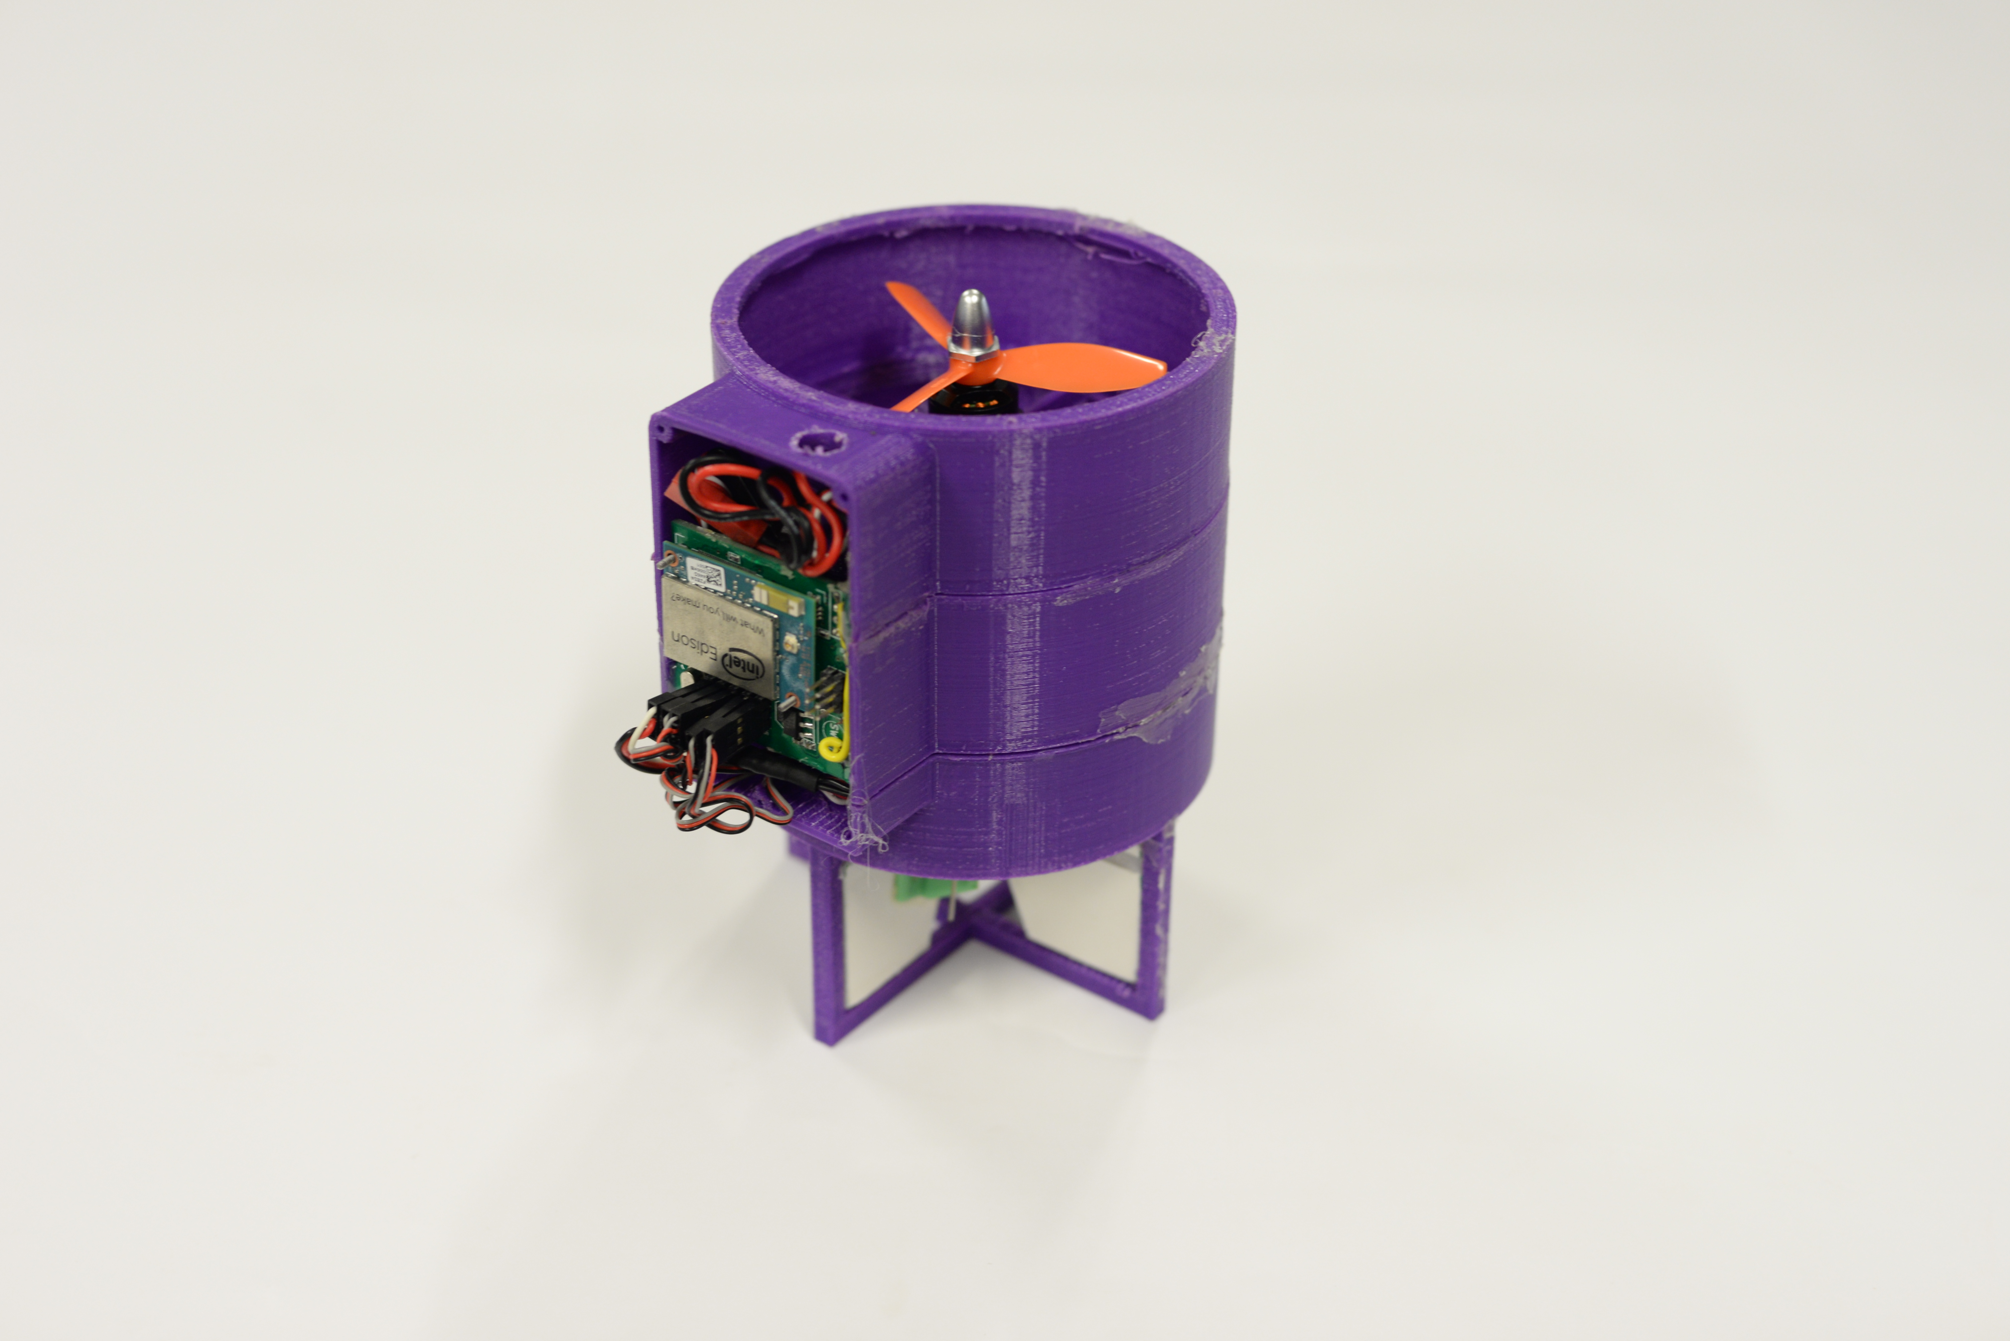 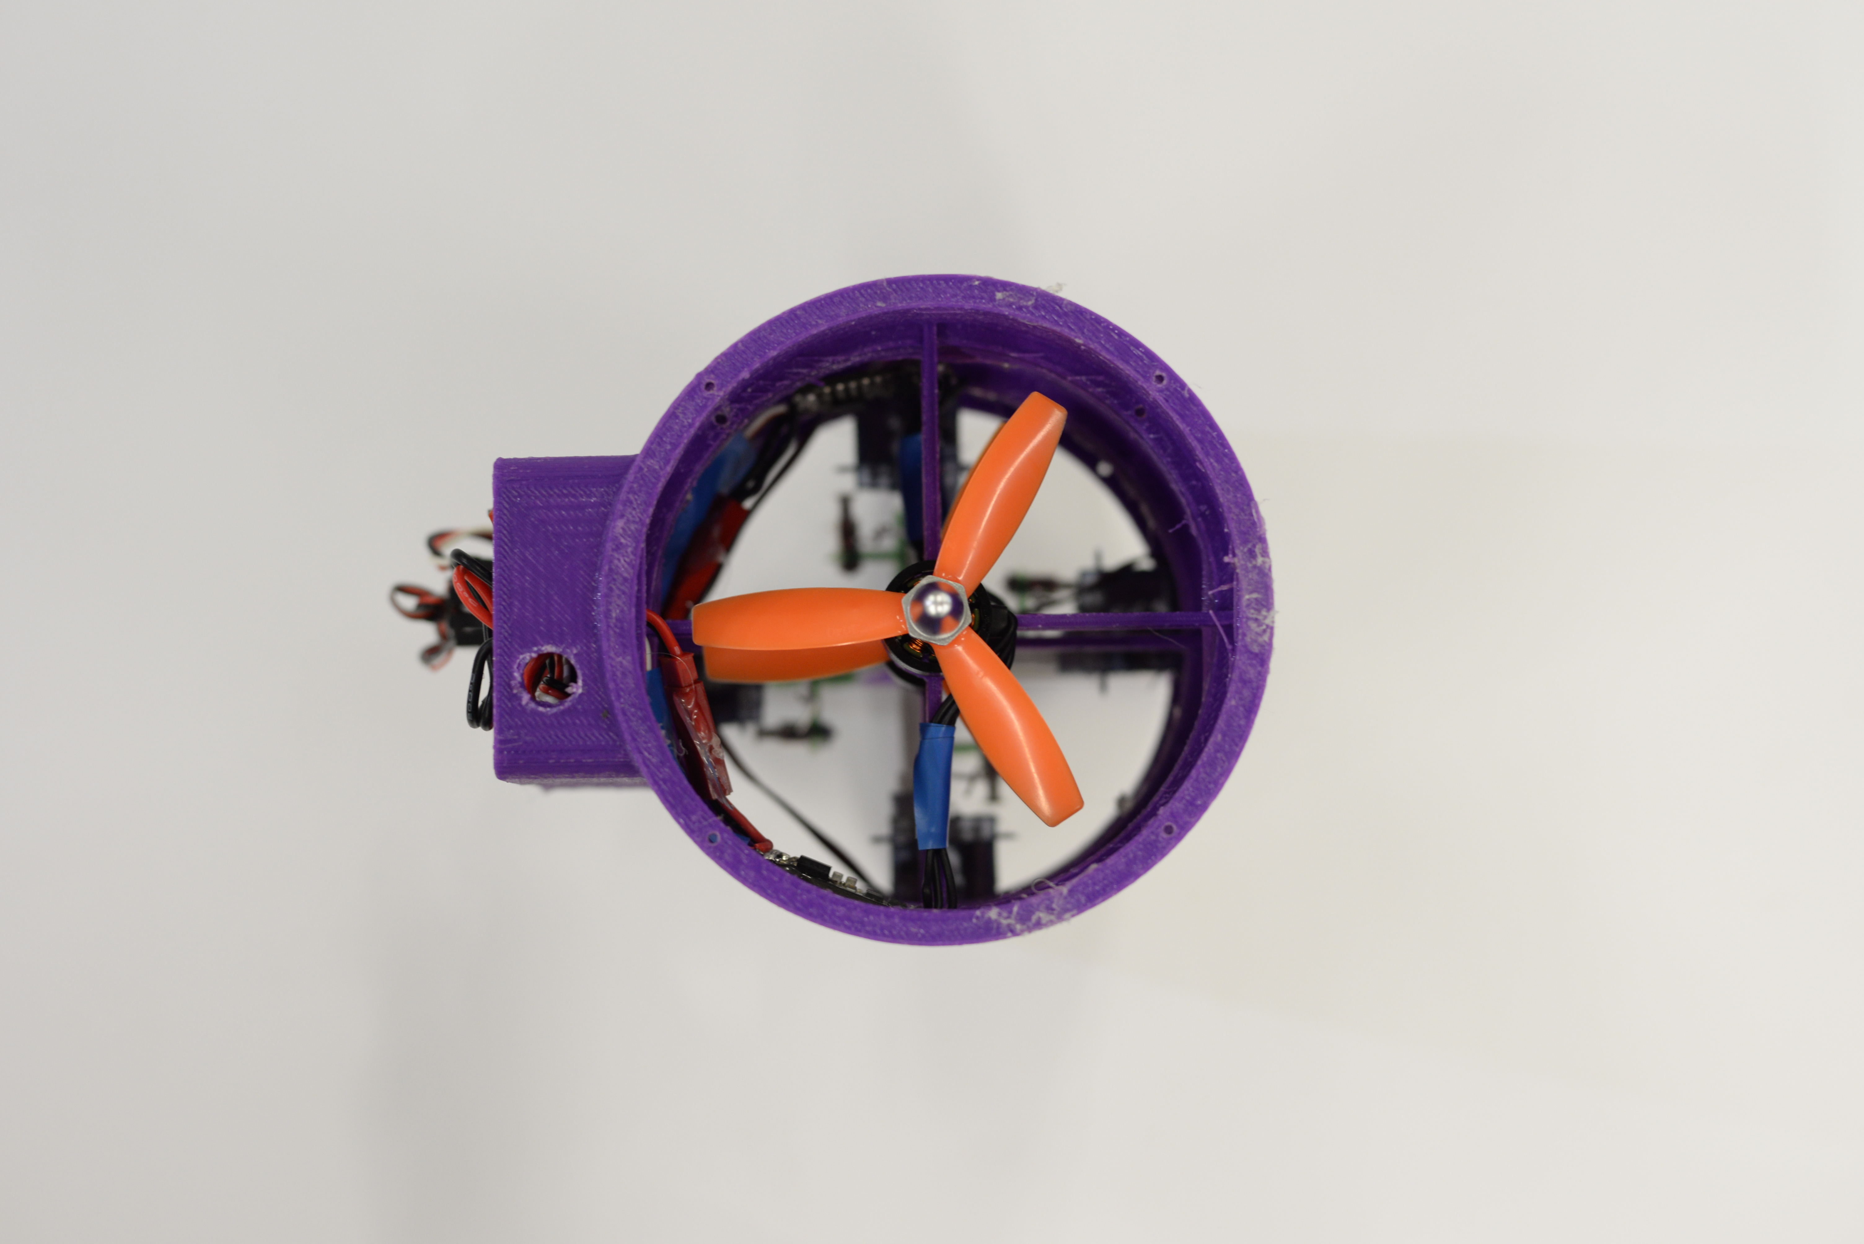

**Figure 2: Image of the functional SentiBot platform (Top-Down view)**

**Figure 1: Image of the functional SentiBot platform (Perspective View)**

# 

# Electronics Design

## Main Processor

**Table 2: Hardware components of the drone platform**

Component Hardware

Main Processor Dual core 500Mhz Intel Atom

Secondary ATMEGA 328

Processor

Motors 4000KV motors

ESCs 12A XMS series

Batteries 800mAh 4S(14.8v)

Propellers 3x3x4.5

Servos 2.8g ultralight

Thrust 500g

Weight 250g

For an educational platform, the students need to be able to do complicated vision processing tasks which are used in academic research purposes like in oil spill detection.[2] This is because the educational drone platform is intended to cater to a range of students from secondary level to university level. This means that a powerful main processor is required to operate with such CPU intensive processes. The Intel Edison, our main processor, provides a decent amount of computing power operating at 500MHz with 512MB of RAM. It also has 4GB of onboard storage for any applications or programs. Since it runs a flavour of Debian Linux, Ubilinux, it is simple to program it.

## Dual CPU architecture

Although the Intel Edison is a very good microprocessor, it lacks the ability to operate in real time which can only be provided by a microcontroller. By using an additional ATMEGA 328, allowed the platform to gain additional sensor expandability options through getting more GPIO which could be used. To combine the main processor with the lower level processor to get a dual CPU system, a custom PCB is used which makes a very versatile control board for students and researchers to use. The separation of the higher and lower level processing also provides code organization in the software as it allows for the higher and lower level code to be separated. This helps because the students can selectively experiment with the high level software and change code without affecting the lower level code which helps with debugging of algorithms. This works in both direction where students can also edit the lower level code without affecting the higher level code.

## On board sensors

The main sensor which allows for the drone to fly in a stable manner is the Inertial Measurement Unit (IMU). This sensor provides accelerometer and gyroscope information to the secondary processor for the PID loop to keep the drone upright. The sensor also allows for dead reckoning to be used for localization. Another important sensor is the IR distance sensors mounted on the sides. This allows for collision avoidance to prevent the drone from accidentally colliding into walls. There is also an onboard RGB camera which allows for vision processing and complex computer vision tasks to be carried out..

## Flight Drive system specifications

The power electronics consists of 4 1C 1200mAh batteries, 2 30A super light ESC’s and 2 4000kV 1306 motors. The motors have a max current draw of 8A each and taking into consideration that the max thrust of each motor is 370g the gram per current rating for each motor is 46g/A. Since the weight of the SentiBot is about 320g, the nominal current draw during a hover would be about 7A. That gives a flight time of about 10-15 minutes. This is a pretty respectable amount of flight time for a conventional drone. This configuration can of course be changed in case the user requires more power or more flight time.

## Power Supply management

In terms of power management, 3 voltage levels are required- 14.8V from the battery, 5V for the control board and 3.3V for the control circuity. Since the drone’s ESCs do not come equipped with a built in BEC( Battery eliminator circuit ), an external switching regulator is used to supply clean 5V for the control board. The onboard 3.3V LDO further steps down the voltage from 5V to 3.3V.

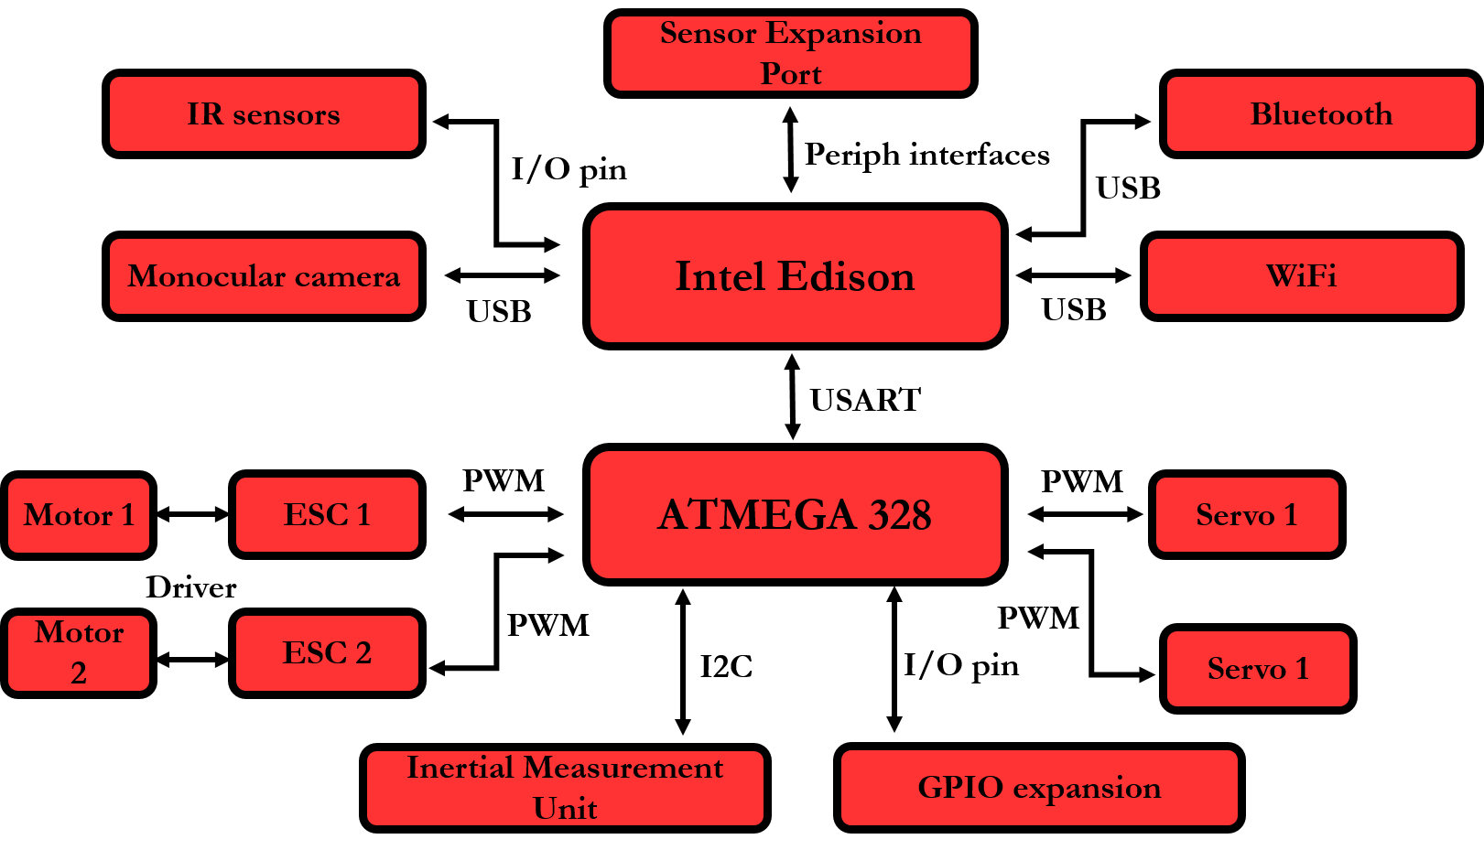

**Figure 3: Hardware peripheral wire-up diagram in the SentiBot**

# Software Design

## An important aspect of creating a student friendly drone platform would to be provide modular and easily modified software. The software will also have to easy to understand and be intuitive to allow for easy control of the drone. There are primarily 2 ways this drone can be operated. The first way is the manual mode, where the drone is flown by an operator manually and information is streamed down from the drone to the ground-station for analysis. This makes the SentiBot act as an Unmanned Aerial Vehicle (UAV) with manual control. Another way this drone can be operated is in the fully autonomous mode. In this mode, the drone is able to make intelligent decisions to achieve a certain task on its own.

There are also mainly 2 main subsystems in the software. The first subsystem is the lower level processing which encompasses the control loop to stabilize the drone, the GPIO management, the IMU reading and writing, and some low level sensor reading and obstacle avoidance. This subsystem is intended to run in the ATMEGA 328.

The second subsystem is the higher level subsystem. This higher level subsystems encompasses the more complex tasks like navigation, localization, vision algorithms, object identification and other essential tasks for autonomous flight. This system also manages communications infrastructure between the drone and the ground station and acts as a relay between the ground-station and the lower level subsystem.

## Lower level subsystem

### PID Loop

The control algorithm used in the SentiBot is similar to all the other control algorithms used in typical quadcopters. Implementing the classic PID control loop, we allow the sensor data to be mapped into error values that can be used to compensate for frame errors and instabilities in the frame. The control algorithm first reads the I2C bus and outputs the data from the IMU which has been preprocessed by the Digital Signal Processor (DSP) on board the IMU. This allows for the control algorithm to get filtered and processed yaw-pitch-roll (**ypr**) data for use in the PID algorithm.

The processed **ypr** values are sent through the respective PID loops for their specific axis and used to obtain 3 error values for each of the x, y and z axis. These error values can then be used to output to the servos, which then tries to bring the system back to the stable state by moving the specific servos. The barometer also enables altitude hold using another PID loop. All of the control algorithm runs onboard the ATMEGA 328.

### Communication Infrastructure

There a few communication methods that are being used within in the system. As shown in *Figure 3,* A I2C peripheral interface is used between the lower level subsystem and the Inertial Measurement Unit (IMU). Additionally, a USART interface is used between the ATMEGA 328 and the Intel Edison which runs the higher level subsystem. This communication is managed by our software which uses the Multi-Wii protocol to do the serial communication. [5]

### Multi-Wii firmware

The firmware which runs the lower level subsystem is based off the open source Multi-Wii project. We made some minor modifications to the firmware such that it is more suited for the coax-copter platform but we used the stock Multi-Wii PID loop controller and communication infrastructure. The fact that the open source Multi-Wii framework was used adds to the appeal of our platform in that it is quite modular and easy to modify for the end user. The Multi-Wii platform is also well documented for the students to easily pick-up and understand.

### Collision Avoidance

Another important function that the lower level subsystem carries out is the simple collision avoidance system based on the 4 IR sensors installed in the bot. This runs in the lower level system to ensure that no higher level algorithms can override the base instinct of the robot to prevent crashes and damage to itself and the environment. This is done through a modification that is made to the Multi-Wii framework which adds collision avoidance functionality to it.

## Higher Level subsystem

The higher level subsystem consists of the code that allows for additional communication infrastructure with the groundstation and the autonomous system. The higher level subsystem runs on the Intel Edison which has built in Wi-Fi and Bluetooth which allows for communication to be set-up.

### Autonomous infrastructure

The autonomy of the SentiBots needs to be implemented in a fully modular manner which allows students to easily tap onto resources available online and libraries which allows for students to easily implement autonomy in the SentiBots. Thus, the SentiBots is based on the ROS architecture which is completely open source and currently provides a lot of existing libraries which allows students to easily implement systems into the robots. The ROS architecture is also very commonly used by students and researchers alike and thus they would find it very comfortable to use in the SentiBots.

### Communication setup

The communication system is reliant on the onboard Wi-Fi present in the Intel Edison SoC. It uses the Wi-Fi to connect to a Wi-Fi hotspot set up by the ground station before transmitting data over the Wi-Fi connection. It also transmits telemetry information which is sent to it by the ATMEGA328 through the USART connection port. This basically makes the Edison act as a port forwarder to forward the USART through the Wi-Fi connection to the ground station.

## screenshot_2016-03-07-20-10-03_ioGround-station software

We are currently still in the process of designing and implementing the ground-station. However, we have developed a method to control it through an android app. It uses a simple UDP interface and connects to the Edison via Wi-Fi which allows instructions to be issued to the SentiBot. Lately, a Spektrum satellite receiver has also been added to the spare UART2 port for longer range and lower latency.

**Figure 4: Screenshot of the android app**

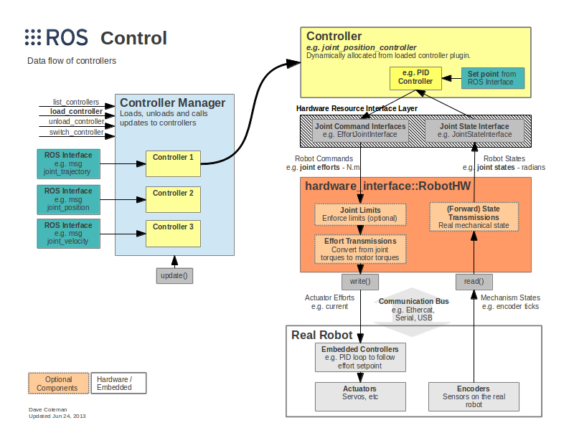

**Figure 5: Standard ROS based architecture [6]**

# Results

Table 1: Motor thrust test results from the manufacturer of the motors

The results of initial testing were positive. The SentiBot shows the ability to lift off, and fly in a stable hover with minimal user intervention. When moved around, the SentiBot platform can accurately maintain its attitude without much user compensation. Currently, the SentiBot is manually controlled but research is underway to demonstrate its autonomous functionality. Furthermore, the drop tests were significantly positive showing that the SentiBot can survive drops from up to 3m high due to its rigid 3D printed PLA frame. These drop tests were conducted through flying to robot up to a certain height and removing power from the motors and measuring how high we could drop from before there was damage to the frame. Only one test run was conducted. In testing, the top speed achieved from the SentiBot is also about 20km/h and flight times are about 15 minutes with normal flying. Furthermore, the SentiBot is able to achieve versatile flight through, under and over several obstacles without any problems due to its small size and form factor. The SentiBot can also easily take collisions with walls or other obstacles without falling due to its shell.

**Figure 6: Comparison between SentiBots and similar platforms]**

# Conclusion

The SentiBot project set out to bring an extremely safe, easy to use and cheap drone for use in educational institutions around the world. It aimed to solve some critical issues in bringing consumer drones to educational institutions for use in student interaction and learning processes by making an ideal drone platform that caters to the cost, ease of use and safety issues presented in those consumer drones. We have created that platform in SentiBots. The competitive pricing with consumer drones while providing one the safest and most hackable drones in the world today makes it highly suitable for educational institutions ranging from secondary schools to tertiary institutions and universities.

Some future work could be conducted into more detailed software which can complement the SentiBot hardware platform as software support for coax-copters in the world today is very limited and rudimentary.

# References

[1]- Droneii.com. (2016). [online] Available at: https://www.droneii.com/wp-content/uploads/2016/01/top20-early-stage-drone-start-up-fundings-1024x769.png [Accessed 9 Oct. 2016].

[2]- Amenyo, John-Thones, et al. "MedizDroids Project: Ultra-low cost, low-altitude, affordable and sustainable UAV multicopter drones for mosquito vector control in malaria disease management." *Global Humanitarian Technology Conference (GHTC), 2014 IEEE*. IEEE, 2014.

[3]- Aznar, F., Sempere, M., Pujol, M., Rizo, R., & Pujol, M. J. (2014, March). Modelling oil-spill detection with swarm drones. In *Abstract and Applied Analysis* (Vol. 2014). Hindawi Publishing Corporation.

[4]- Phys.org. (2011). *Japanese inventor develops flying sphere drone*. [online] Available at: http://phys.org/news/2011-08-japanese-inventor-sphere-drone.html [Accessed 9 Oct. 2016].

[5]- GitHub. (n.d.). *MultiWii*. [online] Available at: https://github.com/multiwii [Accessed 9 Oct. 2016].

[6]- Wiki.ros.org. (n.d.). *ros\_control - ROS Wiki*. [online] Available at: http://wiki.ros.org/ros\_control [Accessed 9 Oct. 2016].

[7]- Jamaluddin, Musa. "Flying Robot Surveyor (To Build FRS Hardware and Remote Control Design with IP Camera)." (2013).

[8]- Uyar, Ekrem Bilgehan, İsmail Uyanık, and Ömer Morgül. "Implementation and Control of an Open Source Quadrotor Platform."

Green, Miranda. "Unmanned Drones May Have Their Greatest Impact on Agriculture." *Daily Beast* (2013).

Kreps, Sarah, and Micah Zenko. "Next Drone Wars; Preparing for Proliferation, The." *Foreign Aff.* 93 (2014):

http://link.springer.com/book/10.1007%2F978-3-319-23760-2

Luukkonen, Teppo. "Modelling and control of quadcopter." *Independent research project in applied mathematics, Espoo* (2011).

Pedretti, D., et al. "CUSTOM HARDWARE PLATFORM BASED ON INTEL EDISON MODULE." (2015).